Question Set 1

1. The relationship between Genus and Species objects is a parent-child relationship (inheritance). The parent class is Genus, while the child class is Species.
2. The relationship between Species and Specimen objects is a has a relationship.
3. 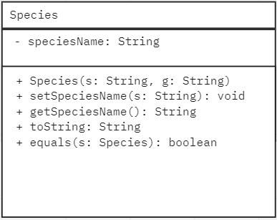
4. **Benefits:**

* Firstly, the benefit that is gain by the programming team is readability. By using relationships, the programming team could avoid duplicate methods and variables, which makes it easier to read.
* Second, the programming team can use method that is defined in the parent class; thus, the code can be reused. It can be used directly which is by keywords such as extends, or by overriding.

1. The Species class inherits all the methods from Genus class, which means that since the toString() method is in the Genus class, the toString() method in the Species class does not return an error.
2. Polymorphism

Question Set 2

1. Encapsulation is one of the object-oriented programming concept that wrap data, functions, methods, and attributes together in a single unit. The variables are private in encapsulation which means that it can only be accessed within the class; variables are protected from unauthorized access which is known as data hiding.
2. **Benefits:**

* Encapsulation protect client’s data from unauthorized or illegal access.
* The fields of a class can be made read-only, write-only, or both. (getter and setter methods).

1. public String getName()

public int getCage()

public Species getTOA()

1. private String name

private int cageNumber

private Species toa

1. 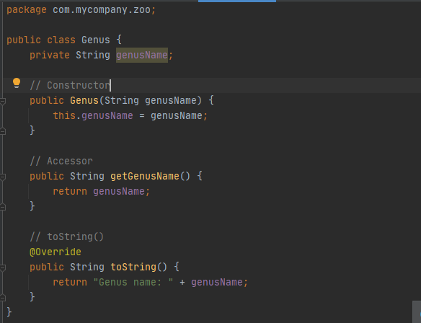
2. **Advantage**

* The advantage of having the Specimen object as a sub-class of the Species object is that Specimen inherits all the properties and behaviors from parent class which is Species. If Specimen inherits from Species, it means that there will be no duplicates, or the properties and behaviors in Species does not need to be defined again.

**Disadvantage**

* The disadvantage of having the Specimen object as a sub-class of the Species object is sometimes, data members in class are left unused, and it may lead to memory wastage.

Question Set 3

1. First, create a new string private variable for markings. Then, add a string parameter for marking and add it in the constructor. Lastly, add the getter and setter methods for marking.
2. 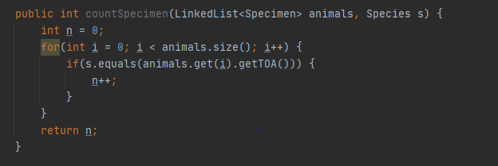
3. **Pseudocode**

listSpecies(Specimen[] animals) {

LinkedList<String> list = new LinkedList<String>

for each animal in animals {

if animal species does not exist in the list {

add the species to the list

}

}

}

Question Set 4

1. **Features:**

* Abstract data types have a behavior that is defined by set of operations that can be used to organize data. An example of abstract data types is list.
* Abstract data types export a type.

1. 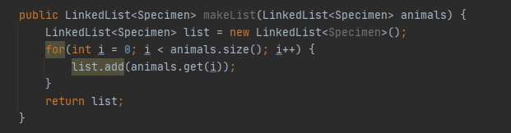
2. 